Total Reader Quick Guide - How to Create a Classroom

Step 1: Click on My Students on the top Menu Bar

Step 2: Select - Click here to add a class and at least one student
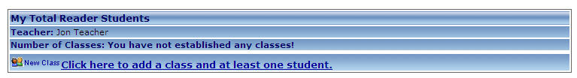

Step 3: Complete the Class Name and select a Grade Level. Then Save.
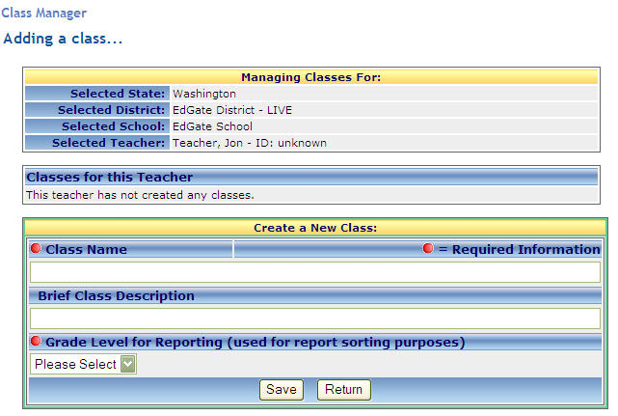

Step 4: You can then Edit Your Profile, Add a New Class or Edit an Existing Class:

