Total Reader Quick Guide - How to Add Students

Step 1: Click on My Students on the top Menu Bar

Step 2: Click on - Edit Class:
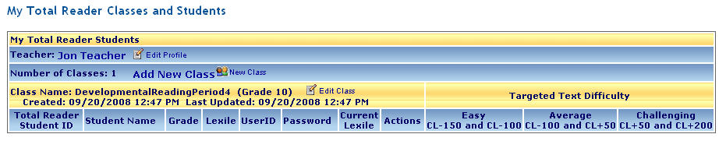
Step 3: Choose students from your school pool by either using the drop down menu to view all students or click on the letter of their last name to reduce the number of names that appear in the drop down menu:
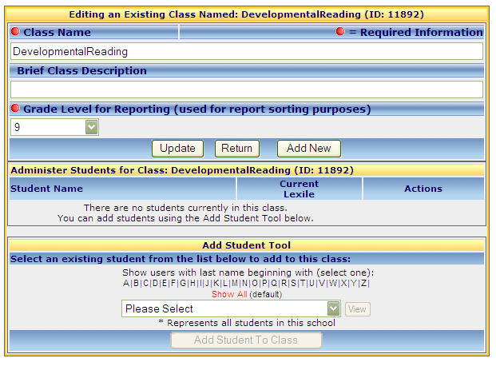
Click on the letter representing their last name
Drop Down Menu
Step 4: Wait, and the students name appears in the box
Step 5: Select the students name and click on
Step 6: A confirmation window appears – click OK
