

Your Name:
Your Username:
Your Password:

Step 1: Login at: www.totalreader.com
2: Click on “Open Total Reader.”
3: Begin reading the 5 paragraphs.
4: You will find sentences that have a number instead of a word. Click on the first number. From the 4 choices, click on the correct word. Once you select the word you cannot change it.
5: When you have completed selecting all the words, scroll to the bottom of the page.
6: Important - Answer Yes or No to the final question and this will re-calibrate your Lexile score.
7: Select another story.

Important - When you have completed 40 answers (inserted words) your Lexile score appears below your name in the Reading Window. This is your first valid Lexile.
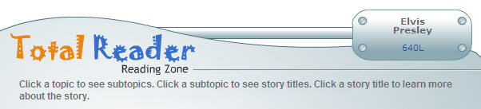

- Select both Fiction and Non-Fiction passages.

- Books are Lexiled to determine their Reading Difficulty.
- Students are Lexiled for their Reading Level (200L – 1800L).

Your Name:
Your Username:
Your Password:

Step 1: Login at: www.totalreader.com
2: Click on “Open Total Reader”
3: Begin reading the 5 paragraphs.
4: You will find sentences that have a number instead of a word. Click on the first number. From the 4 choices, click on the correct word. Once you select the word you cannot change it.
5: When you have completed selecting all the words, scroll to the bottom of the page.
6: Important - Answer Yes or No to the final question and this will re-calibrate your Lexile score.
7: Select another story.

Important - When you have completed 40 answers (inserted words) your Lexile score appears below your name in the Reading Window. This is your first valid Lexile.

- Select both Fiction and Non-Fiction passages.

- Books are Lexiled to determine their Reading Difficulty.
- Students are Lexiled for their Reading Level (200L – 1800L).

